<https://github.com/welborau/cs290-assignment2/blob/master/layout.html>

<https://github.com/flyingg/cs290-assignment2/blob/master/style.css>

<http://web.engr.oregonstate.edu/~lamway/>

<https://www.linkedin.com/pub/eddie-peters/7b/ba/510?trk=pub-pbmap>

<http://web.engr.oregonstate.edu/~lamway/spr261/>

https://github.com/JohnLZeller/Classes/tree/master/CS261

<https://github.com/JohnLZeller/Classes/blob/master/CS261/Assign1/Q1.c>

<http://www.bowdoin.edu/~ltoma/teaching/cs345/spring11/Handouts/pointers.pdf>

<https://github.com/JohnLZeller/Classes/tree/master/CS261/Assign1>

<https://github.com/baylesj/cs261/blob/master/3/2problem/dynamicArray.c>

<http://stackoverflow.com/questions/1608181/unique-random-numbers-in-an-integer-array-in-the-c-programming-language>

<https://github.com/Mankee/CS261/tree/master/Assignment2>

http://en.wikipedia.org/wiki/Linked_list

<https://github.com/guwu/cs261>

<https://github.com/jonziefle/CS261/blob/master/Assignment%202/calc.c>

<https://github.com/jasonblackwell/CS271/tree/master/Assign3>

<https://github.com/jonziefle/CS271/blob/master/Homework%203/CS271_HW3.asm>

<https://github.com/shawnharmsen/CS271/blob/master/Assignment%203/assignment3.asm>

<https://github.com/donatzm/CS271/blob/master/donatzm/Assignment03.asm>

https://github.com/shawnharmsen/CS271/blob/master/Assignment%203/assignment3.asm

<https://github.com/donatzm/CS271/blob/master/donatzm/Assignment01.asm>

report float division

1011 1110 0100 1011

0100 0001 1011 0100

0000 0000 0000 0001

0100 0001 1011 0101

<https://github.com/shawnharmsen/CS271>

<https://github.com/donatzm/CS271/blob/master/donatzm/Assignment01.asm>

1110 1011 0001 1110

0001 0100 1110 0001

0000 0000 0000 0001

0001 0100 1110 0010

http://www.ic.unicamp.br/~celio/mc404s2-03/addr_modes/intel_addr.html

https://github.com/donatzm/CS271/blob/master/donatzm/Assignment01.asm

<http://pastebin.com/yShCf5K0>

https://github.com/search?utf8=%E2%9C%93&q=CS271&type=Repositories&ref=searchresults

http://pastebin.com/Uwc9amAB

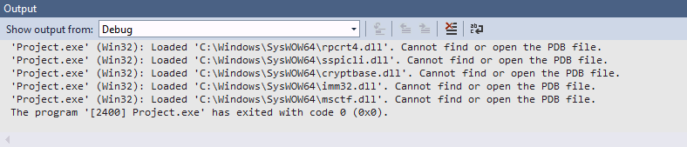

http://www.vsbrown.com/asm.asp

C:\Users\Tanya\Desktop\cs 261\week 2\Q3.c||In function `int main()':|

C:\Users\Tanya\Desktop\cs 261\week 2\Q3.c|18|error: invalid conversion from `void*' to `int*'|

||=== Build finished: 1 errors, 0 warnings ===|